**Chapter 4**

**Design**

* 1. **Design Consideration**

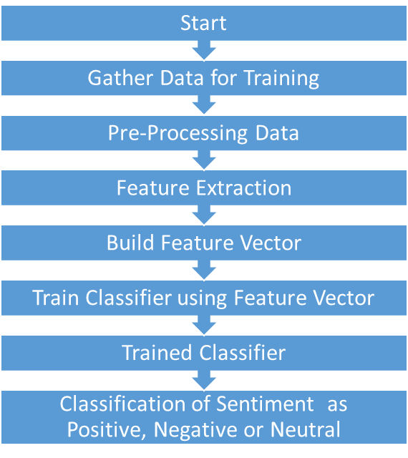

**Fig. 4.1 Control Flow Diagram of System**

* 1. **Design Details**

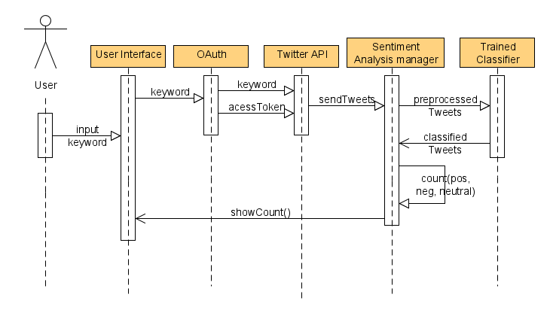

**Fig. 4.2 Sequence Diagram**

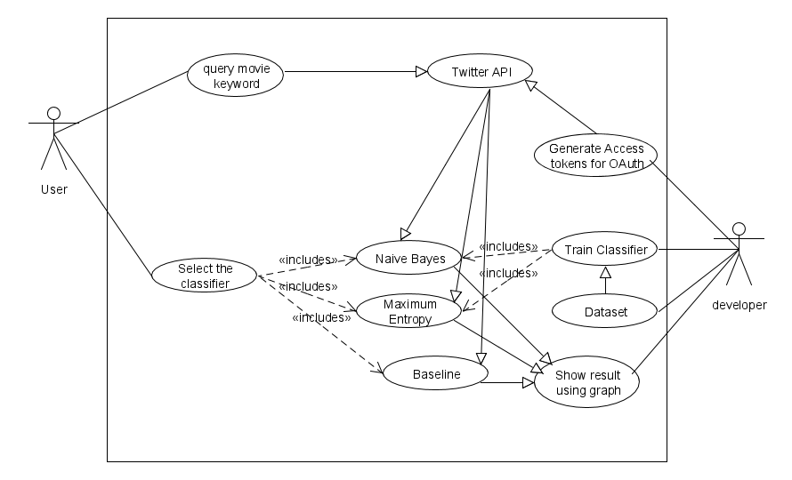

**Fig. 4.3 Use Case Diagram**

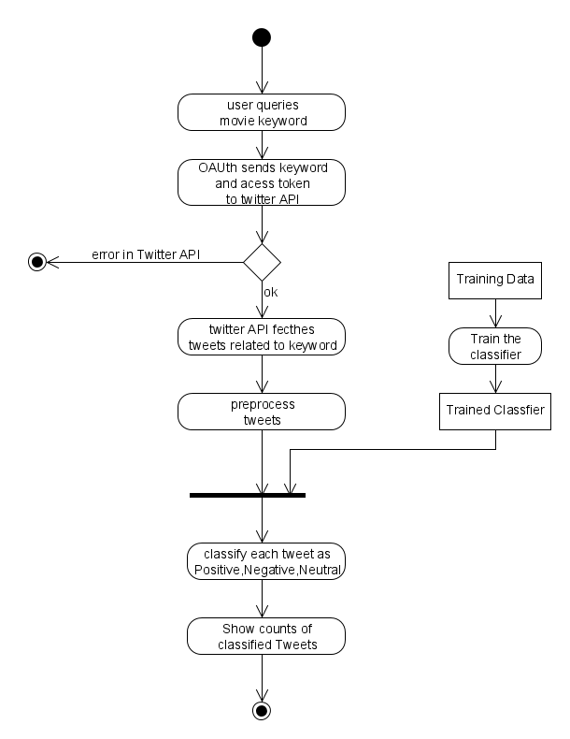**Fig.4.4 Activity Diagram**